**Introduction of SQL**

**Database:** Database is an organized collection of data so that it can be easily accessed. To manage database by using DBMS (Database Management System).

A Database Management System (DBMS) is software that helps you to store, manage, and organize data in a structured way. It allows users to easily create, read, update, and delete data while ensuring that data is secure, consistent, and accessible.

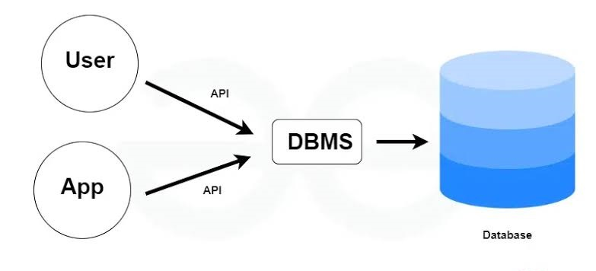**Types of DBMS:**

1. Relation DBMS
2. Non-Relation DBMS

**Relation Database Management System:** A Relational Database Management System (RDBMS) is a type of DBMS that stores data in tables formate like in rows and columns, and also allows relationships between different tables. It helps to organize data efficiently and supports operations like querying, updating, and managing data using Structured Query Language (SQL).

|  |  |  |
| --- | --- | --- |
| **Roll no.** | **Name** | **Class** |
| 1 | Jai | 5th |
| 2 | Amar | 7th |
| 3 | Anuj | 8th |

For example: Mysql, Oracle.

**Non – Relational Database Management System:** A Non-Relational Database Management System (NoSQL) is a type of database that doesn't use tables such as rows and columns. It stores data in other formats like key-value pairs, documents, graphs, or wide-column stores. For example: Mango DB, Red’s.

**SQL:** It stands for Structured Query Language. It is a programming language that is used to access, manage and manipulate data in relational databases. It allows you to perform tasks like retrieving, inserting, updating, and deleting data by using simple commands like SELECT, INSERT, UPDATE, and DELETE.

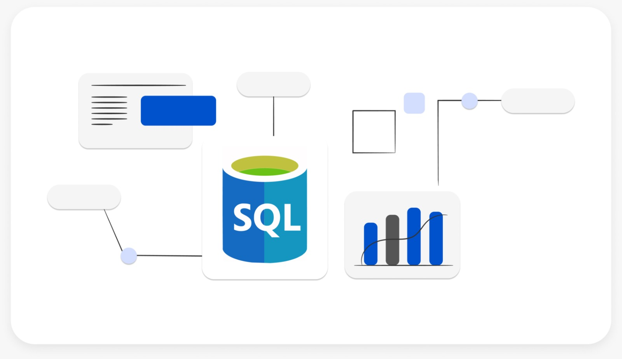

**How does SQL work?**

SQL works by allowing you to communicate with a database through queries. When you write an SQL query, you're asking the database to perform a specific task, like retrieving data, adding new data, or updating existing data. The database processes your query, searches through its tables, and returns the results or makes changes based on the instructions you've given.

**Process of SQL:** When we are executing the command of SQL on any Relational database management system, then the system automatically finds the best way to carry out our request, and the SQL engine determines how to interpret that particular command.

Structured Query Language contains the following four components in its process:

* Query Dispatcher
* Optimization Engines
* Classic Query Engine
* SQL Query Engine, etc.

A classic query engine allows data professionals and users to maintain non-SQL queries. The architecture of SQL is shown in the following diagram:

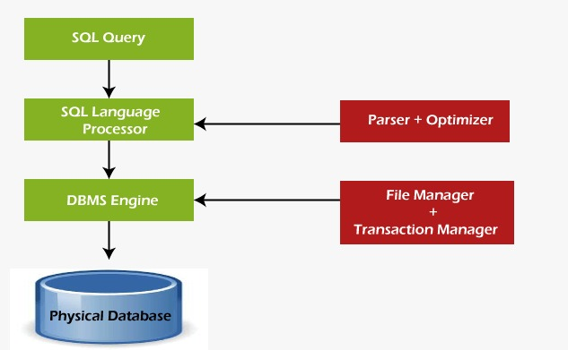

**Parsing:** In this process, Query statement is tokenized.

**Optimizing:** It optimize that best algorithm for the byte code.

**Important terms:**

**Data:** Data is a collection of row facts & figure or information.

**Information:** It is useful data.

**Language:** It is a way to communicate each other.

**Table:** It is a collection of rows and columns.

**SQL Commands: SQL** Commands are like instructions to a table. It is used to interact with the database with some operations. It is also used to perform specific tasks, functions, and queries of data. SQL can perform various tasks like creating a table, adding data to tables, dropping the table, modifying the table, set permission for users.

SQL Commands are mainly categorized into five categories:

1. DDL: Data Define Language
2. DML: Data Manipulating Language
3. DCL: Data Control Language
4. TCL: Transaction Control Language
5. DQL: Data Query Language

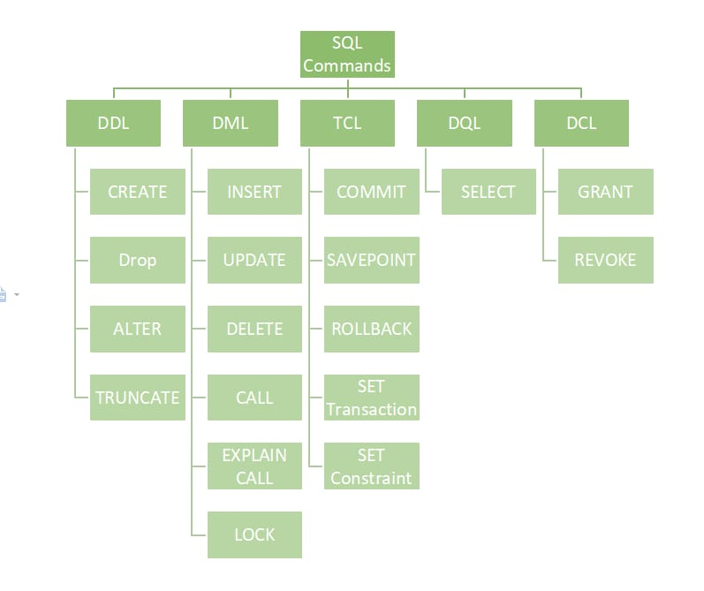

**Data Define language:** It is used to defining, altering and deleting database structures such as tables, indexes, and schemas. It simply deals with descriptions of the database schema and is used to create and modify the structure of database objects in the database. DDL further also have 4 commands such as:

**CREATE:** It is used to create a new table or database.

**SYNTAX:**

CREATE TABLE table_name (column1 data_type, column2 data_type,……);

**DROP:** It is used to delete a permanent table or database.

**SYNTAX:**

DROP TABLE table_name;

**ALTER:** It is used to add new column in table, also used to delete a column, it is used to rename the column header, it is used to modify the data type of column.

**SYNTAX:**

ALTER TABLE table_name ADD COLUMN column_name data_type;

**TRUNCATE:** It is used to delete the all value from the table.

**SYNTAX:**

TRUNCATE TABLE table_name;

**DATA MANIPULATION LANGUAGE:** It is the component of the SQL statement that controls access to data and to the database. Basically, DCL statements are grouped with DML statements. Mainly DML include 3 commands such as:

**INSERT:** It is used to insert values in particular rows.

**SYNTAX:**

INSERT INTO table_name(column1,column2,…..) VALUES(value1,value2,…..);

**UPDATE:** It is used to replace value at the place of old text or number, it is also used to add value in a cells.

**SYNTAX:**

UPDATE table_name SET column1 = value1, column2 =value2 WHERE condition;

**DELETE:** Itis used to delete the value of rows.

**SYNTAX:**

DELETE FROM table_name WHERE condition;

**DATA CONTROL LANGUAGE:** It includes commands such as GRANT and REVOKE which mainly deal with the rights, permissions and other controls of the database system. These commands are used to control access to data in the database by granting or revoking permissions.

**GRANT:** It is used to give the permission to other user to modify the data.

**SYNTAX:**

GRANT privilege_type[(column_list)] ON [object_type] object_name TO user [WITH GRANT OPTION];

**REVOKE:** It is used to restrict the permission.

**SYNTAX:**

REVOKE [GRANT OPTION FOR] privilege_type[(column_list)] ON [object_type] object_name FROM user [CASCADE];

**TRANSACTION CONTROL LANGUAGE:** Transactions group a set of tasks into a single execution unit. Each transaction begins with a specific task and ends when all the tasks in the group are successfully completed. If any of the tasks fail, the transaction fails. Therefore, a transaction has only two results success or failure. In TCL, there are 3 commands to understand such as:

**COMMIT: It** is used to save permanent data.

**SYNTAX:**

COMMIT;

**SAVEPOINT:** It is used to save temporary data.

**SYNTAX:**

SAVEPOINT savepoint_name;

**ROLLBACK:** It is used to delete the last step to work or data.

**SYNTAX:**

ROLLBACK;

**DATA QUERY LANGUAGE:** It is used for performing queries on the data within schema objects. The purpose of the DQL Command is to get some schema relation based on the query passed to it. This command allows getting the data out of the database to perform operations with it.

**SELECT:** It is used to retrieve the data from the database.

**SYNTAX:**

SELECT column1, column2,……FROM table_name WHERE condition;